In order to simulate daily database CURD operation, we create the following tables and schedule database job to run CURD operations.

1. dml.sql

It will create 4 database tables as below.

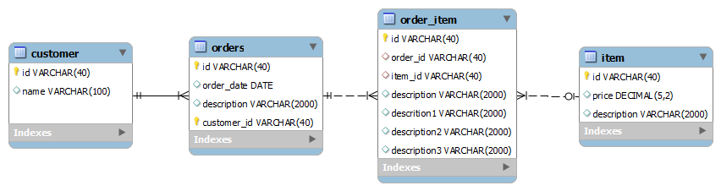

1. curd.sql

This procedure will simulate daily database operation including read, update and delete

1. delete all contents of all tables  
   *delete * from customer;  
   delete * from orders;  
   delete * from item;  
   delete * from order_item;  
   commit;*
2. insert data into tables

*FOR customer_id IN 0..99*

*LOOP*

*INSERT*

*INTO customer VALUES*

*(*

*'customer_'*

*|| customer_id,*

*'customer_name_'*

*|| customer_id,*

*dbms_random.string('A', 20)*

*);*

*COMMIT;*

*END LOOP;*

*FOR order_id IN 0..20000*

*LOOP*

*INSERT*

*INTO orders VALUES*

*(*

*'order_'*

*|| order_id,*

*'customer_'*

*|| ROUND (dbms_random.value(0,99)),*

*sysdate,*

*dbms_random.string('A', 20)*

*);*

*IF remainder(order_id, 10000) = 0 THEN*

*dbms_output.put_line ('commit order at ' || order_id);*

*COMMIT;*

*END IF;*

*END LOOP;*

*COMMIT;*

*FOR item_id IN 0..20000*

*LOOP*

*INSERT*

*INTO item VALUES*

*(*

*'item_'*

*|| item_id,*

*dbms_random.string('A', 20),*

*ROUND (dbms_random.value(1,999))*

*);*

*IF remainder(item_id, 10000) = 0 THEN*

*dbms_output.put_line ('commit item at ' || item_id);*

*COMMIT;*

*END IF;*

*END LOOP;*

*COMMIT;*

*FOR item_order_id IN 0..100000*

*LOOP*

*INSERT*

*INTO order_item VALUES*

*(*

*'order_'*

*|| ROUND (dbms_random.value(0,20000)),*

*'item_'*

*|| ROUND (dbms_random.value(0,20000)),*

*ROUND (dbms_random.value(1,999)),*

*'', '','',''*

*);*

*IF remainder(item_order_id, 10000) = 0 THEN*

*dbms_output.put_line ('commit order_item at ' || item_order_id);*

*COMMIT;*

*END IF;*

*END LOOP;*

1. update table order_item with random long varchar2

*update item_order set description = 'xxxxxxxxxxxxxxxxxxxxxxxxxxxxxxxxxxxxxxxxxxxxxxxxxx' || dbms_random.string('A', 20) , description1 = dbms_random.string('A', 200), description2 = dbms_random.string('A', 400),description3 = dbms_random.string('A', 600);*

*commit;*

1. run queries with group by and order by

*SELECT SUM(item.price) totalprice*

*FROM order_item,*

*orders,*

*item*

*WHERE orders.id = order_item.order_id*

*AND order_item.item_id = item.id*

*GROUP BY orders.id,*

*order_item.item_id;*

*SELECT order_item.description d1, item.description d2, orders.description d3*

*FROM order_item,*

*orders,*

*item*

*WHERE orders.id = order_item.order_id*

*AND order_item.item_id = item.id*

*and order_item.description like 'xxxxxxxxxxxxxxxxxxxxxxxxxxxxxxxxxxx%'*

*order by order_item.description;*